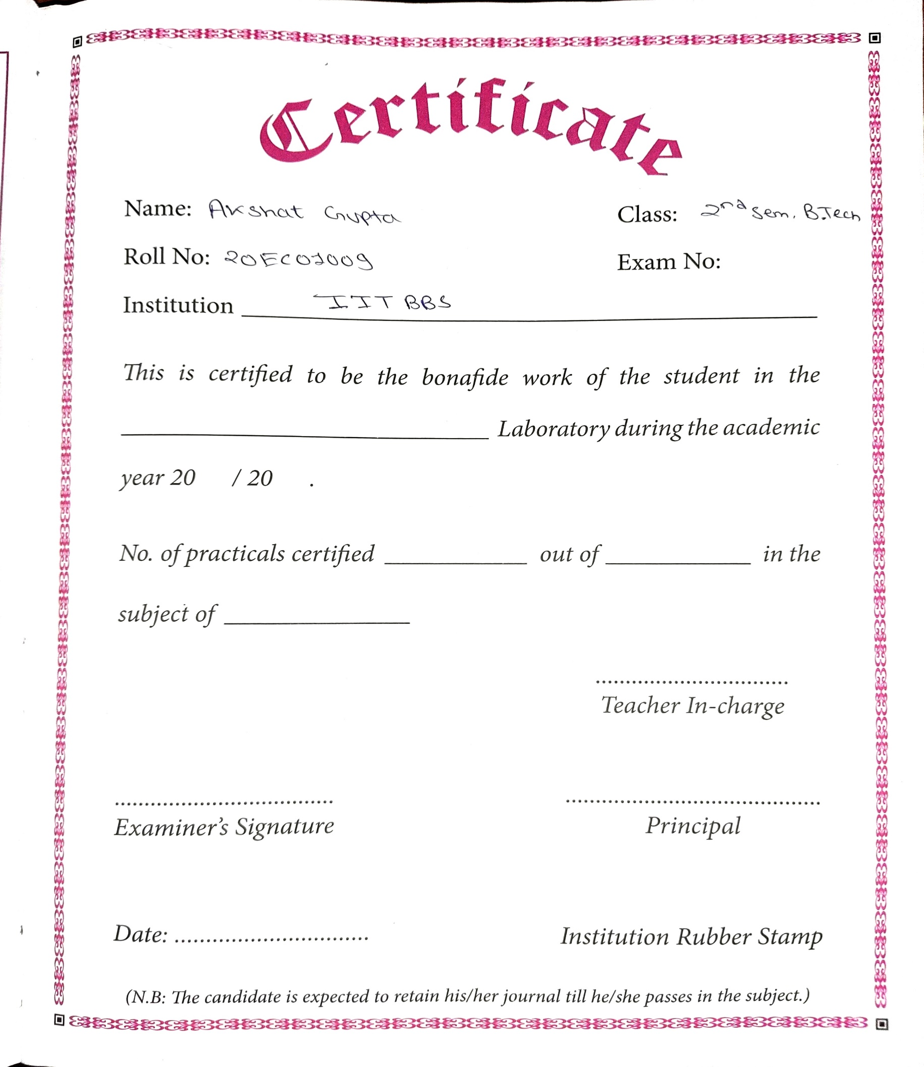

**Aim of the experiment:**

To make a square section from a round bar using forging technique.

Tools / Apparatus required:

1. Furnace

2. Tongue

3. Anvil

4. Swage Block

5. Sledge hammer

6. Flatters

**Raw Material:**

MS rod of 25mm diameter and 100mm length, from which a square section of 20mm X 20mm

has to be formed.

**Theory:**

**Introduction:**

Forging is a process of shaping the metal components in cold or hot condition by the application of impact or pressure. Forging is a manufacturing process involving the shaping of metal using localized compressive forces. The blows are delivered usually

with a hammer (often a power hammer) or a die.

**Practical Application:**

Forging is generally used for those components which require high strength and resistance to shock or vibration sudden impact of load and uniform properties For example in automobiles chassis of all vehicles, front and rear axle, wheel drums, spring blades, rocker arm, gear shifter and connecting rod etc. are made by forging operation.

**1. Advantages of doing forging** **operation**

a. Forging gives comparatively tougher product compare to casting.

b. The fatigue strength and creep resistance of forge product is higher.

c. Forge product has higher mechanical properties.

d. Low cost operation.

e. This process does not required special skill operator.

f. Variety of shapes can be formed by this process.

**2. Process mechanism –**

Depending upon the working temperature of the forging. Forging can be classified into two types that are hot forging and cold forging.

Hot forging‐ When the forging is done above the recrystallization temperature of the work piece then it is called hot forging,

**Cold forging‐**

When the forging is done below the recrystallization temperature of the work piece then it is called as cold forging

**Advantages of Cold Forging**

Manufacturers may prefer cold over hot forging process; since cold forged parts require very little or no finishing work. Since all bars are annealed before being forged, there is no need for a secondary heat treatment prior to machining. Another significant advantage is the material savings achieved through near net shapes. The initial weight of the workpiece equals the final weight of the cold forged component. Cold forged parts offer a good level of attainable dimensional accuracy and excellent surface quality.

The economic advantages combined with high production rates and long die life are more than enough to convince many manufacturers that cold forging is the best option for them.

**Disadvantages of Cold Forging**

Depending on the manufacturer’s requirements, some of the cold forging characteristics may

turn out disadvantages; e.g. only simple shapes in high volumes can be shaped. The achievable deformation levels and shaping grade are much more limited compared to

stamping. Therefore, if the customer is searching for a specific customized component, cold forging won’t be the best alternative.

A second more significant disadvantage is that cold forged metals are less ductile, which makes them inappropriate for certain configurations. Also, because of the grain structure that

gives the material its strength, residual stress may occur.

It is important to mention that cold forging extrusion for example requires also a heat treatment to eliminate possible cracks, creeks hardening or rafters. As a consequence of the above statements, cold forging cannot be used on every steel grade,

particularly on those with low ductility or sensitivity to strain hardening.

**Advantages of Hot Forging**

The high temperature during hot forging enables the highest possible level of material deformation and the access to complex 3D geometries. Hot forged components possess increased ductility which makes them desirable for many configurations. Also, as a technique hot forging is more flexible than cold forging, since customized parts can be manufactured.The excellent surface quality allows a wide range of finishing work as polishing, coating or painting, tailored to customers’ specific need. Hot forging materials are available all over the world which has a positive impact on their final price.

**Disadvantages of Hot Forging**

The properties of hot forged metals are obtained by subsequent heat treatment. This requires additional cost, which can be avoided if using cold forging (except in some cases as softening,

annealing or relaxation). Less precise dimensional tolerance is another possible disadvantage of hot forged components compared to the cold forged ones. The cooling process should be also performed

under special conditions; otherwise there is a risk of warping. Also, the grain structure of forged metals may vary and there is always a possibility of reactions between the atmosphere and the workpiece.

**3. Basic types of forging**

**i.) According to the arrangement of Die forging operations are classified as :**

a.) Open Die Forging: This forging process uses flat dies or no die. This is mostly hot forging process in which the work piece heated and hammered to obtain desire shape. This process produces rough product.

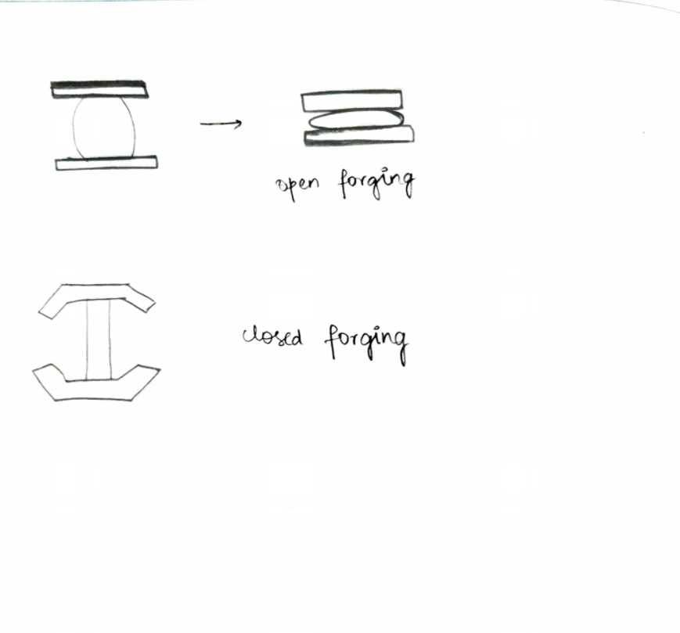

b.) Close Die Forging : Close die forging is a process in which a set of impression die is used to produce desire shape on work piece. Mostly these products do not need any finishing process. This process required higher force.

**ii.) According to the Forging equipment:**

a.) Smith forging: Smith forging is traditional method of metal forming. It is open die forging method in which the work piece is placed on a stationary anvil and a hammer strikes and deform the work piece. The force is applied either by manually or power hammers.

b.) Drop Forging:

Drop forging is done in closed impression dies. An automatic

hammer applied the force in series of blow by dropping action. In this type, a sudden applied force is used.

c.) Press Forging:

Press forging is similar to drop forging except it uses continuous squeezing type applied force

by the hydraulic press. This process increases the length and decrease its cross section of

work piece.

d.) Machine Forging:

Machining forging is an upsetting process in which the cross section of work piece increases and length decreases.

**4. Different tools used for basic types of forging operation**

The tools and the equipment used their applications in numerous forging operation are as given.

**Anvil:**

The anvil forms the support for blacksmith’s work when hammering. The body of the anvil is

made of mild steel face welded on the body. The beak is used for bending as shown in Fig.

There is a square hole at the end which is used for holding the shank of the lower member of pair

of tools.

Anvils vary up to about 100-150kg and should stand with about 0.75 m from the floor. This

height may be attained by resting the anvil on a cast iron or wooden base.

**Swage Block:**

This forge shop tool is used for many squaring, sizing, heading, bending and forming operations.

It is 0.25m or more wide may be used either flat or edgewise in the stand as shown below

Hand Hammers:

Two kinds of hammers are used in hand forging:

a. The hand hammer used by the smith himself.

b. The sledge hammer used by the striker.

Hand Hammers may further be classified as:

a. Ball peen hammer

b. Straight peen hammer

c. Cross peen hammer

a. Ball peen Hummer: This is the most common form of the hammer and is sometimes called as engineer’s hammer or chipping hammer. The peen has a shape of a ball which is hardened and polished as

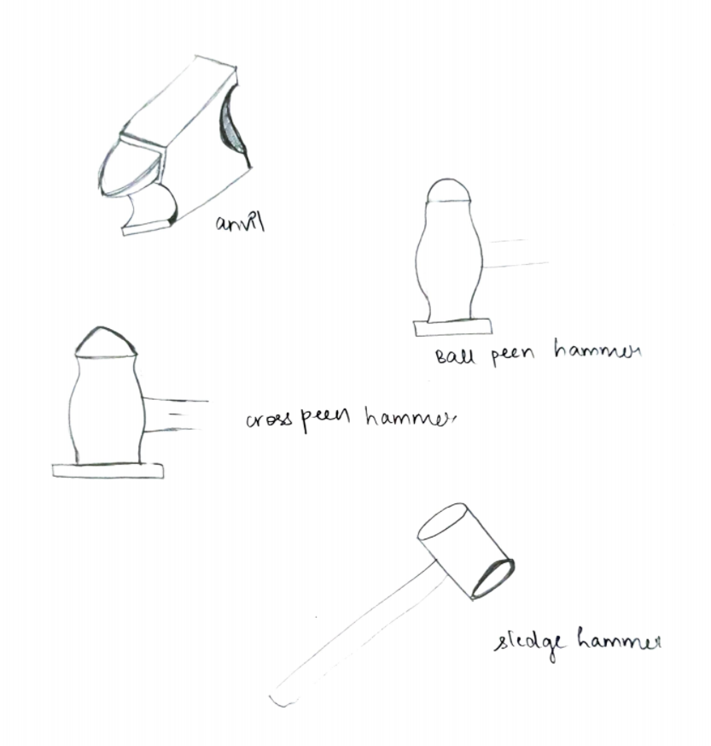

shown in Fig. . This hammer is chiefly used for chipping and riveting. The size of the hammer varies from 0.11 to 091 kg.

b. Cross peen hammer: This is similar to a ball hammer in shape and size except the peen which is across the shaft or eye as shown in Fig. below. This is mainly used for bending, stretching, hammering into shoulders, inside curves etc. The size varies from 0.22 – 0.91kg.

c. Straight peen hammer: Where it is necessary to strike metal a blow with the minimum damage to the surface, a soft hammer, called mallet is used as shown in Fig. below. Mallet heads go by the

numbers or by the diameter is the head. They are made of raw hide, hard rubber, copper, brass, lead etc.

Hammers are made of cast steel and the ends are hardened and tempered. The striking face is slightly convex. The weight of a hand hammer varies from about 0.5 kg to 2 kg while the weight

of a sledge hammer varies from 4 to 10 kg.

**Sledge Hammer:** The sledge hammer is heavy and has a long handle as shown in Fig. below. Its weight ranges

from 4 to 10 kg. It is used for heavy work.

**Tongs:**

The work to be forged is generally held in tong. The tongs generally used for holding work are:

a. The Gad tong is used for general pick up work, either straight or tapered.

b. The straight lip fluted tong used for square, circular and hexagonal bar stock.

c. The ring tong used for bolts, rivets and other work of circular section.

d. The flat tong used for holding for holding work rectangular section.

**Swages**

Swages are used for work which has to be reduced and finished to round, square or hexagonal from.

These are made with half grooves of dimensions to suit the work being reduced. Swages consists

of two parts – the top part having a handle and the bottom part having a square shank which fits

the handle and the bottom part having a square shank which fits into the haedie hole in the face as

shown in figure

**Fullers:**

Fullers are used for necking down a piece of work. They are made in top and bottom tools as in

case of swages. Fullers are made in various shapes and sizes according to the needs, the size

denoting the width of the fuller edge as shown in the figure above.

**Flatter:**

This is used to flatten and smooth the metal. It is used under a sledge hammer to flatten

and smoothen the metal, particularly after its thickness has been reduced using fullers.

**FORGING operations:**

(1) Drawing down

(2) Upsetting

(3) Bending

**Drawing down:**

The operation of spreading or thinning action and is accomplished by striking the work piece with flat dies. Due to impact of die on metal its thickness is reduced and length is increased

**Upsetting:** This is just opposite to drawing and involves increasing of the cross‐sectional area usually by pressing or hammering in the direction parallel to the original ingot axis.

Only the part to be upset is heated to forging temper and the bar or work is then struck at the end, usually between the hammer and the axis as shown in figure.

**Bending:** It is one of the most important processes of forging and is very frequently used.

Bends may be classified a sharp cornered bends or more gradual bends. The operation is

performed by hammering the metal over the edge of the anvil or over a block of metal held

in vice.

**Procedure:**

Collect the required raw material of MS circular bar of 25mm diameter and 100mm length.

Place the raw material in the furnace and heated until it become red hot enough for hammering.

The specimen is heated till it red hot. (Temperature around 1000 – 1300° C).

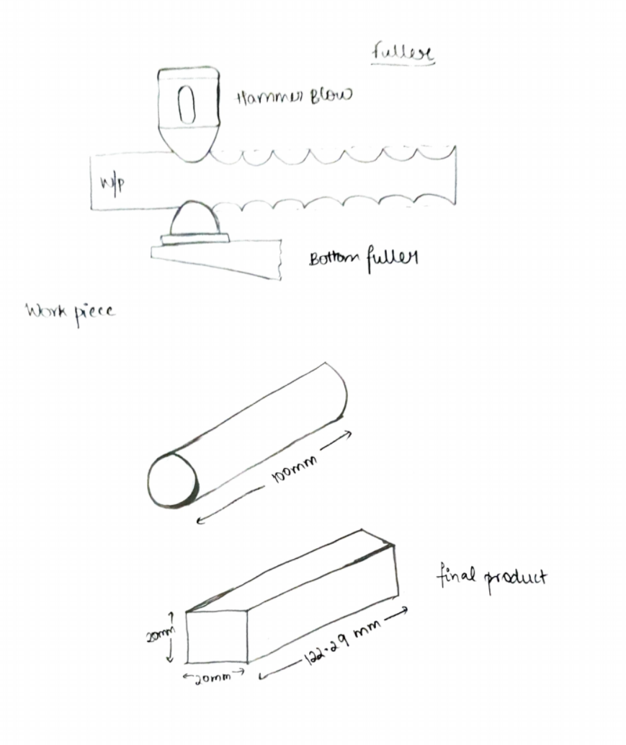 When the material is in the red hot state, it is said to be in the plastic state.

The red hot specimen is then placed on the anvil and held by tongs

Hit the job hard by using the sledge hammer by holding one end with the help of tongs.

Change the position of the job and repeat hammering to change the rod from round to square.

Repeat heating and hammering until the required shape is obtained.

A flatter is used to obtain a fine finish on the job.

Finally, the job is cooled by dipping in water.

**Safety and precaution:**

1. Always avoid the use of damaged hammers.

2. Never strike a hardened surface with a hardened tool.

3. No person should be allowed to stand in line with the flying objects.

4. Always use the proper tongs according to the type of work.

5. The anvil should always be free from moisture and grease while in use.

6. Always wear proper clothes, foot‐wears and goggles.

7. The handle of the hammer should always be tightly fitted in the head of the hammer.

8. Always put out the fire in the forge before leaving the forge shop.

9. Always keep the working space clean.

10. Proper safety guards should be provided on all revolving parts.

11. During machine forging, always observe the safety rules prescribed for each machine.

12. One must have the thorough knowledge of the working of the forging machine before operating it.



**Result:**

Thus the round rod is transferred to a square rod for the given dimensions.